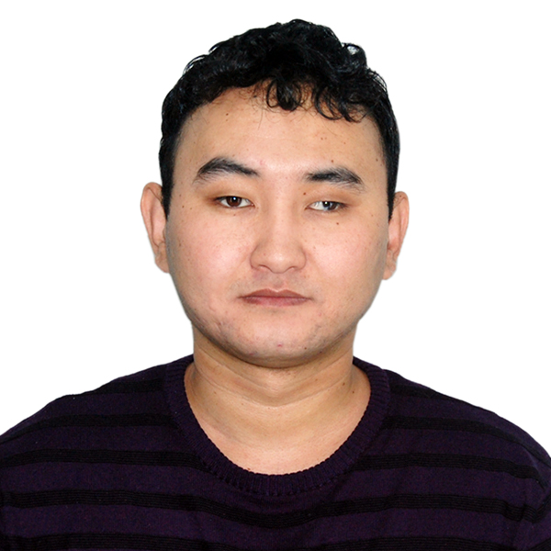
RESUME

NURZHAN KUANYSHBAIULY TOLEU
Birth date: 23/04/1986
Marital status: single
Kazakhstan, Almaty, Zhibek Zholy ave, 81/146
Mobile phone: +7 705 334 36 99,
Skype: holysoul_toleu
E-mail: holysoul_toleu@mail.ru,

Education: Karaganda State University named after E.A. Buketov
2003-2007 Foreign Languages Faculty
Department of English-Kazakh philology (B.A.)

Work experience:

Now
Full professional freelancer since May, 2012

Hardware manuals experience:
(LG, Panasonic, Sony, De Longi, Braun e.c.)
More than 4 mln. words - 2007-2018

Software/IT experience:
IBM/Microsoft/Huawei/Uber e.c.
More than 2 mln. words - 2012-2018

Automobile translation experience:
Nissan/Toyota/Lexus
341 000 + words 2015 - 2017
John Deer
More than 100K words since 2016

Legal translation experience:
Not less than 500 K words – 2007-2018

15/12/2011-02/05/2012
English-Kazakh translator
Neotech Kz Company, Almaty, Kazakhstan
(SAP projects: localization of accounting, HR and other software)

18/05/2009-14/12/2011
English-Kazakh translator
Palex Ltd. Company, Almaty, Kazakhstan
(Localization of Microsoft, Philps, Nokia, LG, Samsung, BD and other technical, legal or medical projects)

10.2007-04.2009
English-Kazakh-Russian translator
“The Bureau of privatization and Investments” Ltd., Karaganda, Kazakhstan
(Translation of administrative and land management documents, business letters)

July-September 2007
English-Kazakh-Russian translator/interpreter
for National Boxing Team of India
“Mittal Champion Trust” Co., Temirtau, Kazakhstan
(Interpreting, sports, conferences, general)

June-October 2006
Assistant of manager, operator/cashier
“Parklawn Shel” gas station
Rockville city, Maryland, USA
(International language skills improvement program)

Interests and Skills: -Language skills: English-fluent, Kazakh-native, Russian-fluent, -Available tools:
Trados Studio 2015
Transit NXT
OpenTM 2
Memoq 8
Across
Tstream
Memsource
Smartling (online)
Translation Workspace

QA tools:
Xbench
Verifika
QA Distiller
Y-Snell-Tools
CHKPII GUI

Translation languages:
English<>Kazakh
Russian<>Kazakh
English<>Russian
Payments are accepted through Paypal, Payoneer or bank transfer.

0.05 – 0.09 USD per word

